Influences on Demand on GOP Surgeries

Introduction

The following report seeks to build a model to determine demand on GP surgeries by the elderly. To do this, 6 factors were recorded on a sample of 4000 individuals aged 66 or over as well as the number of GP visits made by each during the study. These factors, along with the variable relating to each factor in the below model were:

1. Number of hospital stays made during the study
2. Self-perceived health status (Excellent, Average or Poor)
3. Number of diagnosed chronic diseases
4. Gender (Male or Female)
5. Number of years in education
6. Whether the participant had private health insurance (Yes or No)

The number of GP visits made is used to determine demand on GP surgeries as requested. The significance of each factor was assessed, and a model was developed allowing for the approximate prediction of the number of GP visits a given elderly individual will make to been determined. Below the proposed model is presented as well as a discussion on the observed relationships between the factors and GP visits made. It should be noted that such a model, since built only with data on people aged 66 and over, should only be used to predict the expected number of GP visits for people in this age bracket. A separate model built from individuals of all ages would be needed to make predictions for individuals of all ages.

The Model

A generalised linear model was developed using the sample data. All recorded factors were found to be significant, meaning all of them affected the predicted number of GP visits. The proposed model is shown below (with values rounded to two decimal places), and an example prediction is made to highlight how the model is used.

Log(Y) = 1.03 + 0.16(X1) - 0.36(X2i) + 0.25(X2ii) + 0.15(X3) - 0.11(X4) + 0.03(X5) +0 .20(X6)

Where:

|  |  |
| --- | --- |
| X1 | Number of hospital stays made during the study |
| X2i | 1 if health status is excellent, 0 otherwise |
| X2ii | 1 if health status is poor, 0 otherwise |
| X3 | Number of diagnosed chronic diseases |
| X4 | 1 if male, 0 otherwise |
| X5 | Number of years in education |
| X6 | 1 if participant had private health insurance, 0 otherwise |

*For categories, some options are not represented by a factor. This is because one item of each category is accounted for when the other options equal 0 (for example, a person with average health status would be represented by X2i = 0 and X2ii = 0.

Example: A female (X4 = 0) with ten years of education (X5 = 10) who feels healthy (X2i = 1, X2ii = 0), has private health insurance (X6 = 1), no chronic diseases (X3 = 0) and has made no recent hospital stays (X1 = 0) would have these values inputted into the formula, resulting in an expected number of GP visits of

Y = e^(1.03 + 0.16(0)-0.36(1)+0.25(0)+0.15(0)-0.11(0)+0.03(10)+0.20(1)) = 3.22

In other words, this individual can be expected to make 3.2 GP visits on average.

Relationships Explained

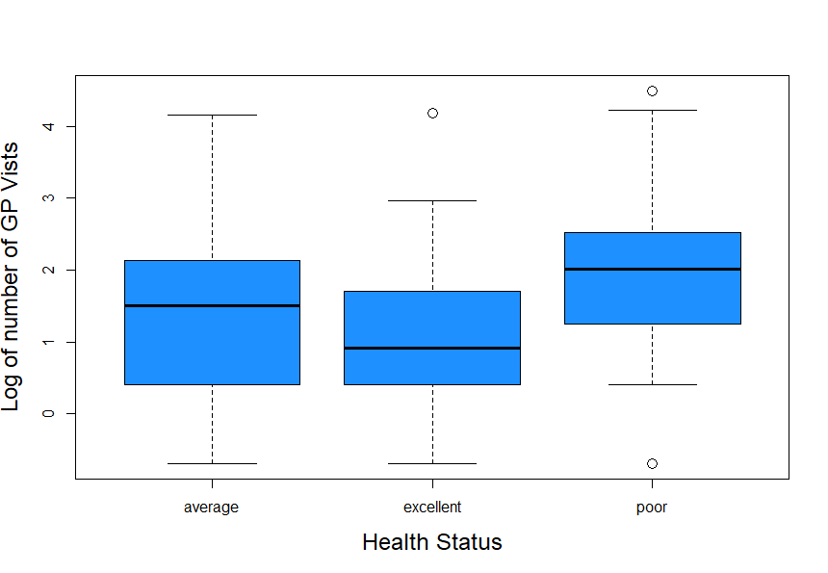The below graphs have been produced with the sample data used to highlight the observed relationships between each factor and the number of GP visits made as well as how they have been incorporated into the model. In the graphs used, the log of the number of GP visits made is used to better highlight the differences between the recorded factors. Any positive relationships between a factor and the number of GP visits made is reflected by a positive coefficient for that factor in the model and similarly, a negative relationship is reflected by a negative coefficient for that factor. Thus, where a positive relationship exists, the higher the value of the factor, the greater the expected number of GP visits. For factors represented by categories, a category with a higher number of GP visits than the value used as the benchmark in the model (in this case, average health status, female gender and no private health insurance) has a positive coefficient on its factor (e.g. +0.25 for poor health status, so a person with a poor health status is given a higher expected number of GP visits to reflect the relationship seen below) while one with a lower number of GP visits is reflected with a negative coefficient (such as -0.11 for males).

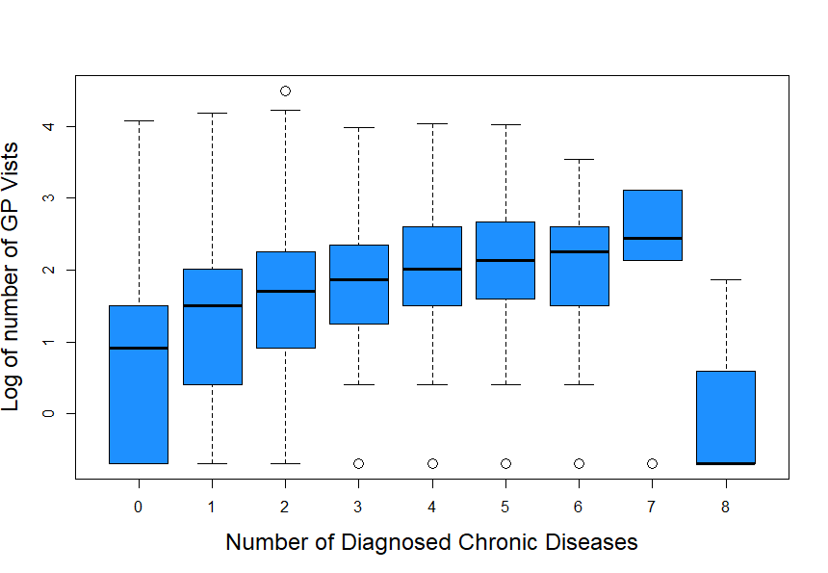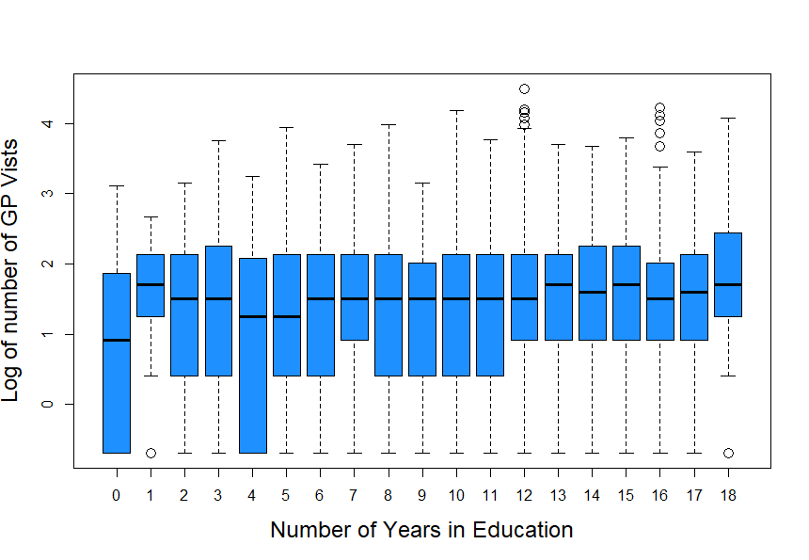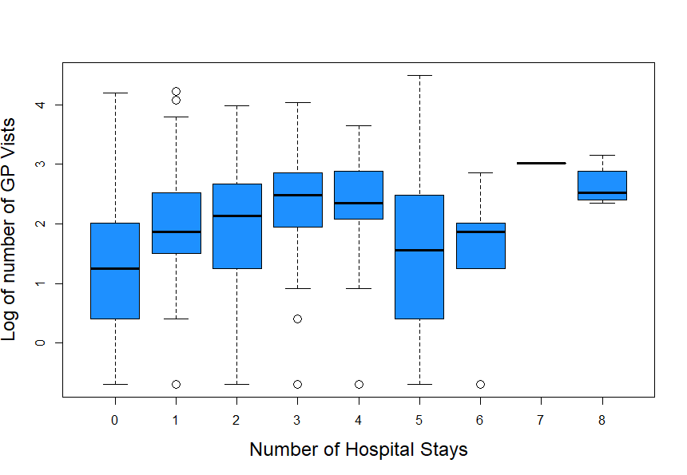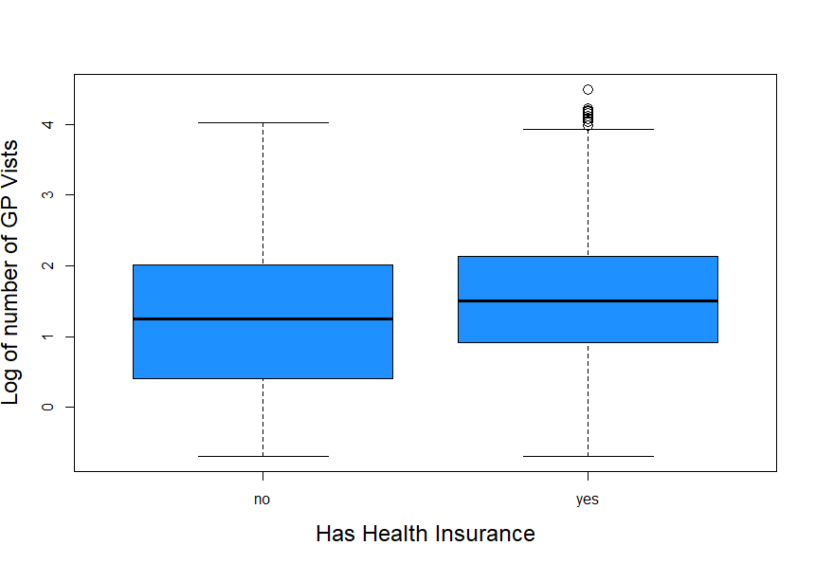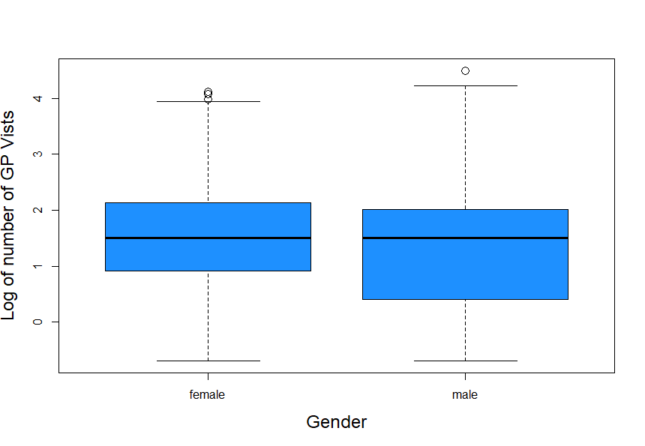

Two oddities observed in the visualisations are the non linear relationship between the number of GP visits and number of hospital stays, potentially indicating a generalised linear model may not be the best method for expression this relationship, and the sudden drop in GP visits for those with 8 diagnosed chronic diseases, potentially indicating people this ill may be under more rigerous surveliance, potentially even staying at hospital full-time, thus making ar fewer GP visits. Due to the nature of generalised linear models, neither of these occurences are reflected in the model.